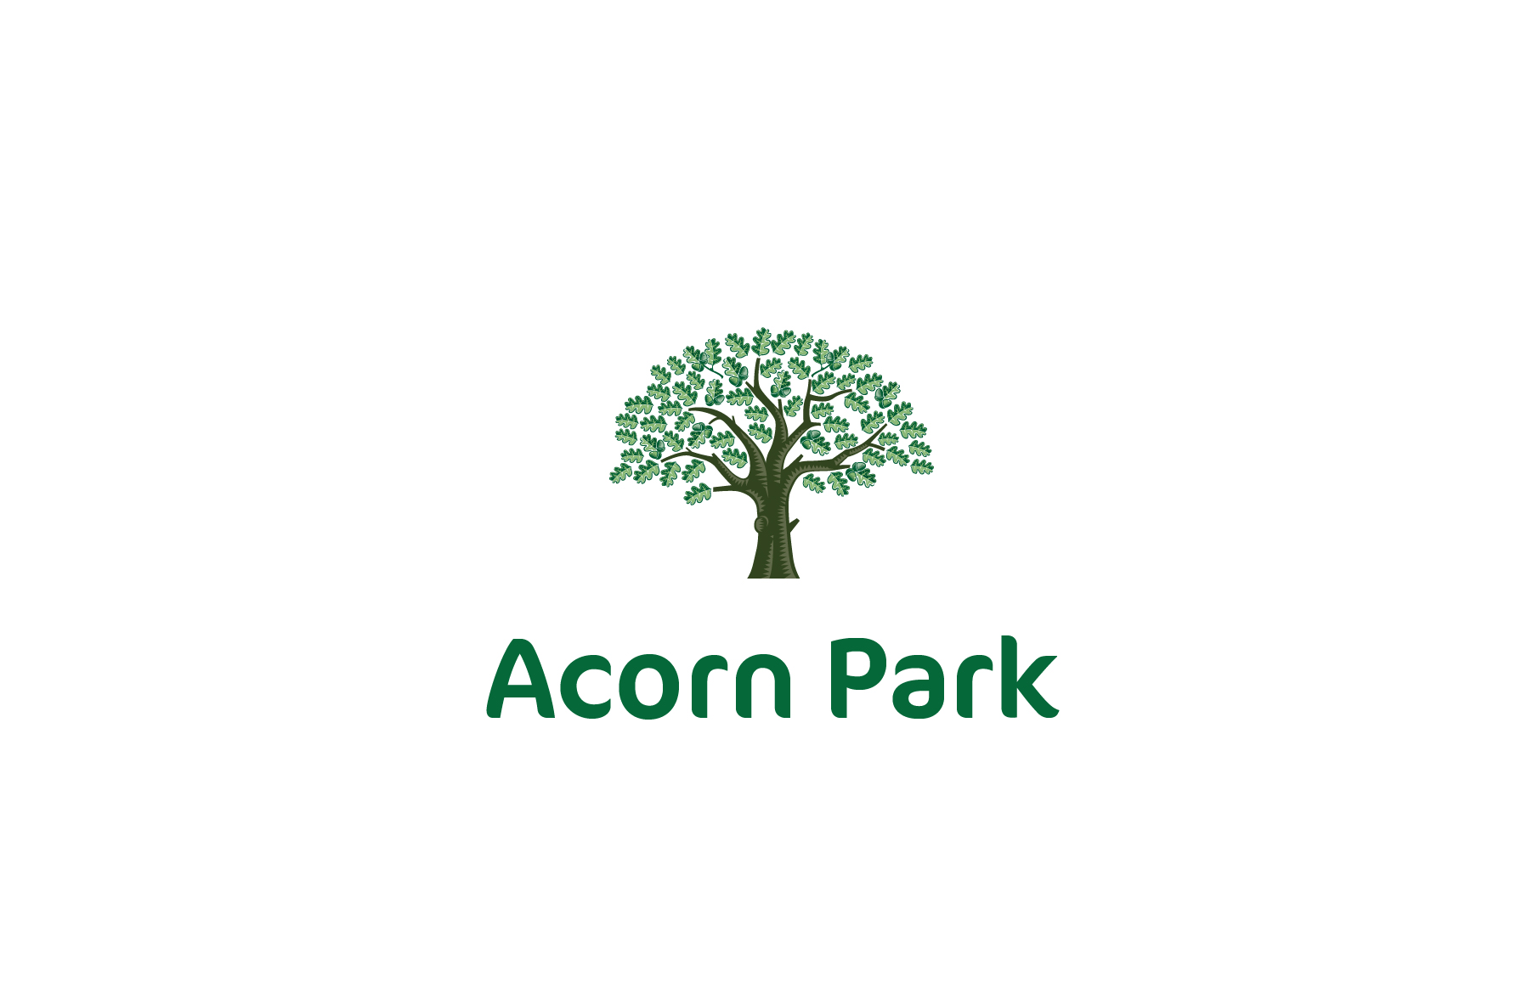
Name: Class:

Date:

School Uniform Order Form

Item | Size | Quantity | Total
Navy Children’s Polo Shirt Short Sleeve | 5-6 (26”)  7-8 (28”)  9-10 (30”)  11-12 (32”)  13 (34”)
Navy Adult’s Polo Shirt Short Sleeve | Small (36”)  Medium (38”)  Large (40/42”)  X-Large (44/46”)
Navy Children’s Sweatshirt | 5-6 (22/23”)  7-8 (23/25”)  9-10 (25/27”)  11-12 (28/30”)  13 (31/32”)
Navy Adult’s Sweatshirt | Small (32/34”)  Medium (34/36”)  Large (38/40”)  X-Large (42/44”)
Navy Children’s Cardigan | 7-8 (23/25”)  9-10 (25/27”)  11-12 (28/30”)  13 (31/32”)
Navy Children’s Full Zip Fleece | 6-8 (24/26”)  8-10 (26/29”)  10-12 (29/31”)  12-14 (31/34”)
Navy Adult’s Full Zip Fleece | Small (38”)  Medium (41”)  Large (44”)  X-Large (47”)

PE Order Form

Item | Size | Quantity | Total
Navy T-shirt | 5-6 (28”)  7-8 (30”)  9-11 (32”)  12-13 (34”)  Adult Small  Adult Medium  Adult Large
Navy shorts | Waist 18-20”  22-24”  26-28”  30-32”  34-36”  38-40”
Navy jogging pants | 5-6 7-8  9-10  11-12  13  Adult Small  Adult Medium  Adult Large
PE bag

Please note that you will be provided with 3 polo shirts, 2 sweatshirts/cardigans one fleece and one item of each of the PE kit free of charge per academic year. Any additional items will need to be purchased at Birds of Dereham online shop.

Please complete form and return to school office.

